Wide Area Network
Tasks
1.
Draw a simple diagram (on paper or using an online tool like draw.io) showing how your phone connects to Instagram's servers from your home WiFi, including the ISP and at least two Wide Area Network (WAN) devices (like routers or switches) in the path.
ANS :
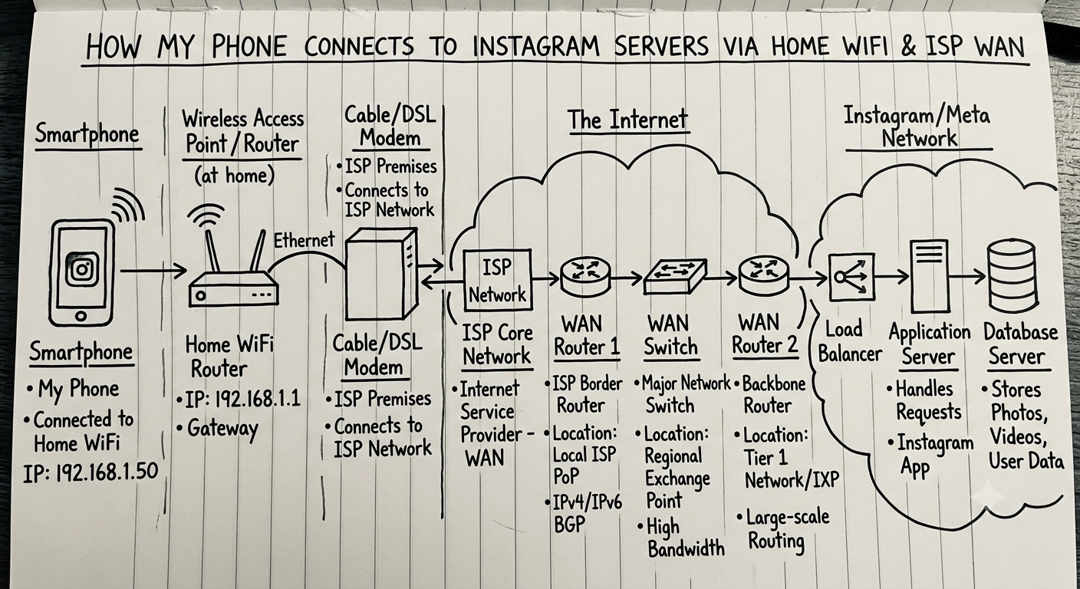

2.
Create a table listing three types of WAN technologies (such as MPLS, Leased Line, and Broadband Internet) and compare them based on speed, cost, and where you might see them used in real life (e.g., Zomato office, IRCTC ticketing, your home).
ANS :
WAN Technology | Speed | Cost | Real-Life Usage
MPLS (Multiprotocol Label Switching) | High | High | Large organizations such as corporate offices and banking networks
Leased Line | Very High, Dedicated | Very High | IRCTC ticketing systems, data centers, large companies
Broadband Internet | Medium to High | Low | Home internet connections, small businesses, cafes

Summary :
- MPLS: Reliable and secure for connecting multiple branches.
- Leased Line: Dedicated connection with guaranteed bandwidth.
- Broadband: Affordable and suitable for homes and small offices.

3.
Research and write a short explanation of how a VPN (Virtual Private Network) uses WANs to let you access apps like Spotify or YouTube securely from a public WiFi at a coffee shop.<br><br><em><strong>Hint:</strong> Focus on how the VPN creates a private tunnel over the public WAN.</em>
ANS :
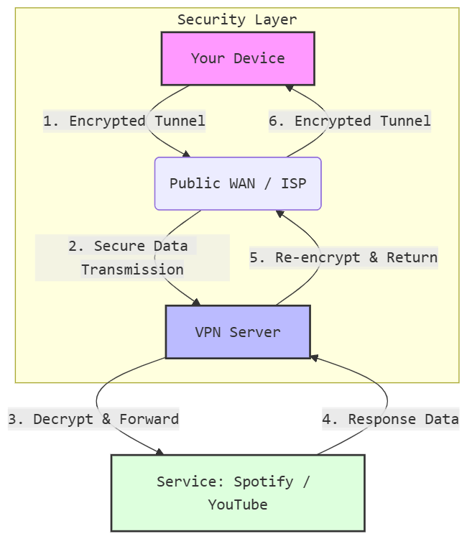

- Encryption at the Source: Before any data hits your local network or the public internet, your device wraps it in an encrypted layer. This ensures that even if someone on the same Wi-Fi intercepts the packets, they see only scrambled data.
- The Intermediate Tunnel: Your internet service provider (ISP) sees that you are connected to a VPN server, but the contents of your traffic (the specific URLs or media you are streaming) remain hidden within the "tunnel."
- The Exit Node: The VPN server acts as a relay. It strips away the encryption to send the request to the final destination. To the service (like YouTube), the request appears to originate from the VPN's IP address rather than your actual location.
- The Secure Return: Data traveling back follows the same logic—it is encrypted by the VPN server before being sent back across the public web to your device.

4.
Imagine Flipkart wants to connect its warehouses in Ahmedabad, Mumbai, and Delhi. Suggest which WAN technology would be best for them and justify your answer with two reasons.
ANS :
If Flipkart needs to connect warehouses in:
- Ahmedabad
- Mumbai
- Delhi
MPLS would be a good choice.
Reasons
- Reliable Connectivity
  - MPLS provides stable and predictable network performance between warehouses.
  - Important for inventory updates, shipment tracking, and warehouse management systems.
- Better Security
  - MPLS creates a private network between locations.
  - Sensitive business data is less exposed than when using the public Internet.

